**CRISM MTRDR Data**

When we import MTRDR Data, around the outside of the image there is no data (as indicate by the 65535 values), these values need to be masked:  
  
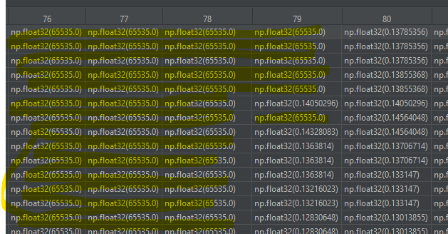  
  
From there, we can use the CRISM Data as is.  
  
However, if we want to do visual overlays like what follows:

* We need to stack 3 wavelengths together to replicate RGB data.
* To do this we either need to apply local or global stretching to that data:
  + Local stretching is to the 3 layers of wavelength data separately.
  + Global stretching to the 3 layers together.
* Stretching is to change the data range from 0.1 – 0.2 to say 0 to 1.source

**The stretching methodology is described in section 5.3 Parameter Threshold Values and Stretching of https://agupubs.onlinelibrary.wiley.com/doi/full/10.1002/2014JE004627)**  
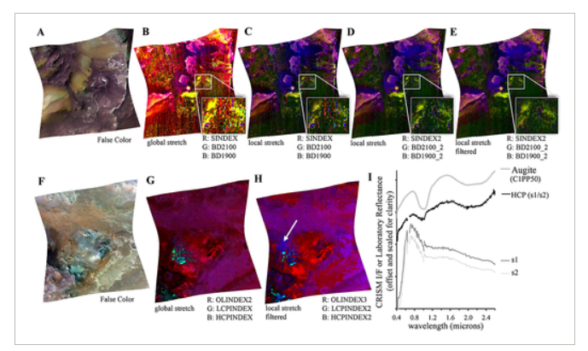

Figure -Visual Overlays

Our replication of “G” above thus far:  
  
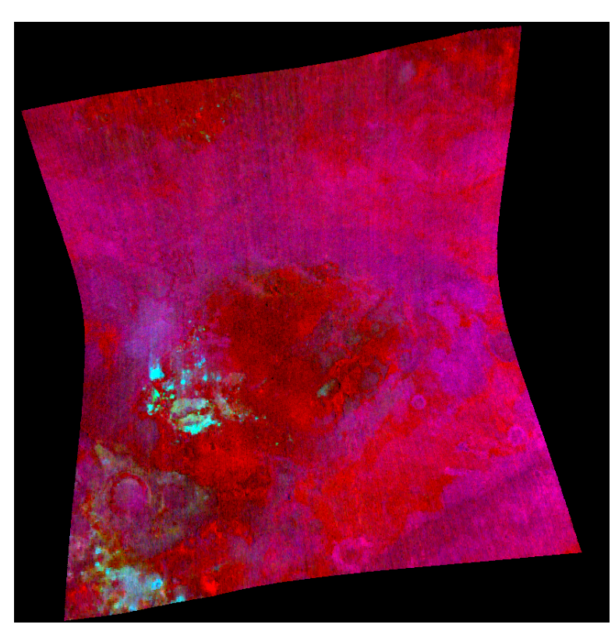

It seems we also need to do this to get the colour boxes on this table which we will need to use as our “barcode” to identify minerals:

Source: Figure 9 - https://agupubs.onlinelibrary.wiley.com/doi/full/10.1002/2014JE004627  
  
